Merging two VPro projects
This is something most user end up doing at some point. To load the Merge Projects options form, select Merge Project in the VPro tab of the ribbon menu and from the Project menu click Merge Projects. It is a fairly simple procedure if a certain amount of care is taken.
The first and number one thing to do is to back up your destination project. If you’ve forgotten where the destination project is located, right-click the project name in the Data Centre menu and select Link Info. The second step is to carefully select your source and destination projects in the Merge Projects form. The third step is to look at the merge options and select the methods you wish to employ. Once you are confident that you’ve selected the options for your merge, click the button Combine Projects.
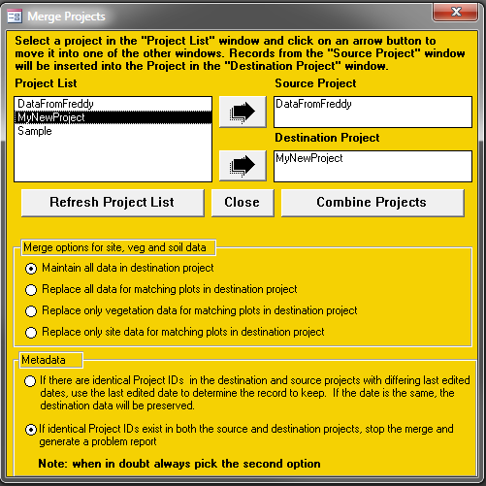

If you’ve selected the second option on the metadata merge section, you may receive a message if there are matching metadata items in both projects. An Excel report will automatically be generated for your convenience. Carefully review the metadata in each project and make any adjustments you feel are needed.
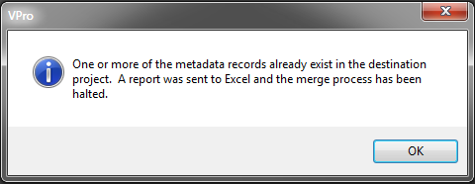
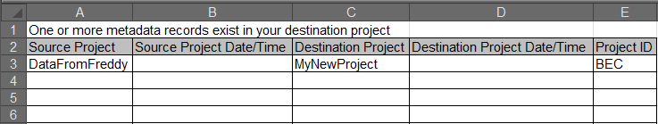

Once you’ve successfully merged your project, you will receive a confirmation message.
